Lab #4 Exercises

Due Date: Sunday December 5 at midnight. You will record your answers in the Lab #4 Exercises ‘Quiz’ on our course Blackboard page.
Use this document to work out the activities/exercises and record your answers for quick reference while taking the ‘Quiz’.
When you are ready, navigate to Lab Assignments -> open the Lab #4 Exercises folder -> and open the Lab #4 Exercises quiz link located at the bottom.
This Lab #4 is worth 60 points.

*Important Note: Don’t wait until the last minute to attempt these lab exercises. If you have questions, email me sooner rather than later. Late submissions will not be accepted unless you have coordinated an extension with me before the due date of December 5.

Week Nine: Groundwater / Glaciers

Water is continuously transferred back and forth between Earth’s different spheres. Label the various components of the hydrologic cycle in the diagram below. (7 pts)
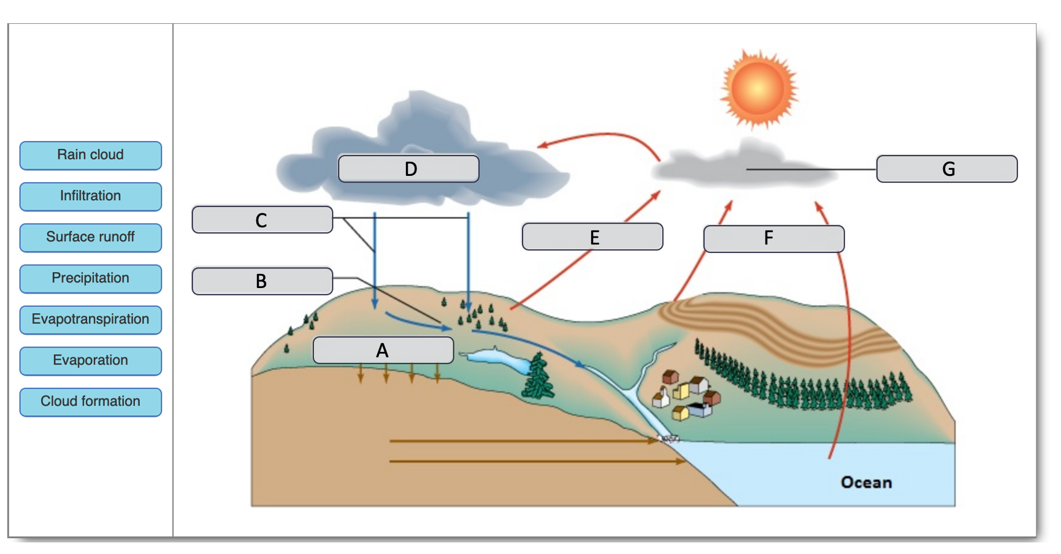

- A: Infiltration
- B: Surface Runoff
- C: Precipitation
- D: Rain Cloud
- E: Evapotranspiration
- F: Evaporation
- G: Cloud Formation
In many circumstances, glacial ice moves downhill due to gravity, despite climate conditions. The size of a glacier is governed by the glacial budget that is calculated as:
- The difference between the zones of accumulation and wastage.
- The zone of accumulation is where the glacier “grows” because more snow and ice accumulate than melt each year. This typically occurs at the higher elevations of glaciers.
- The zone of wastage is where the glacier “shrinks” because annual ice loss exceeds accumulation. This typically occurs at the lower elevations of the glacier.

The snowline is the boundary between the zones of accumulation and wastage. As climate cools over decades, centuries, or millenia, glaciers can become larger as the zone of accumulation grows relative to the zone of wastage. This process lowers the snowline. Over similar timescales of climatic warming, glaciers can decrease in size as the zone of wastage grows relative to the zone of accumulation. This process pushes the snowline higher.

The snowline and zones of accumulation and wastage are labeled in the figure below. For each of the following scenarios described, use the descriptions of a glacier to determine how the climate is changing: 1) the climate is warming, 2) the climate is cooling, or 3) the climate is stable. (8 pts)

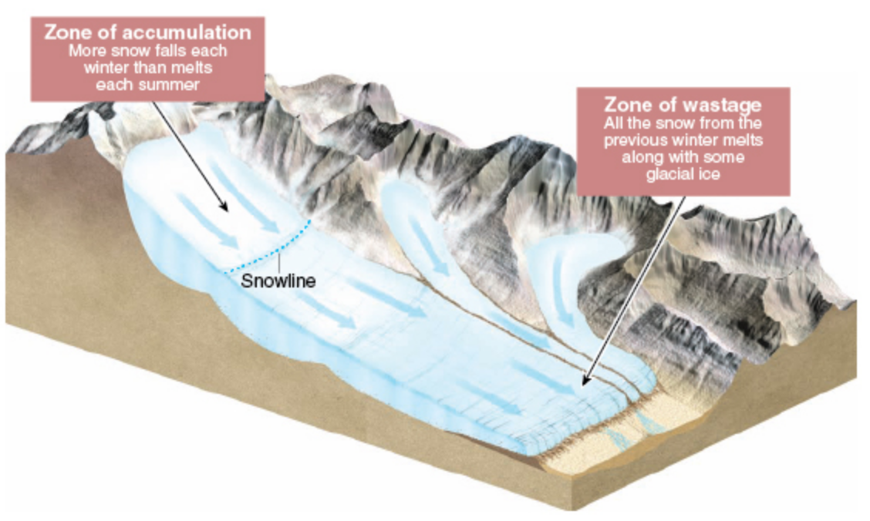
Scenarios:
- The elevation of the snowline increases.
  - 1) the climate is warming
- The zone of accumulation is growing.
  - 2) the climate is cooling
- The zone of wastage is growing.
  - 1) the climate is warming
- The snowline remains at the same position.
  - 3) the climate is stable
Week Ten: Geologic Time / Earth History / Global Climate Change

The following diagram depicts a cross section of the Grand Canyon. Use the relative dating principles described in sections 18.1 of your textbook to indicate the sequence of formation from oldest (first in the sequence) to youngest (last in the sequence). I’ll start you off; the oldest formation is K (the Vishnu Schist) and the youngest formation is G (Muav Limestone). (13 pts)

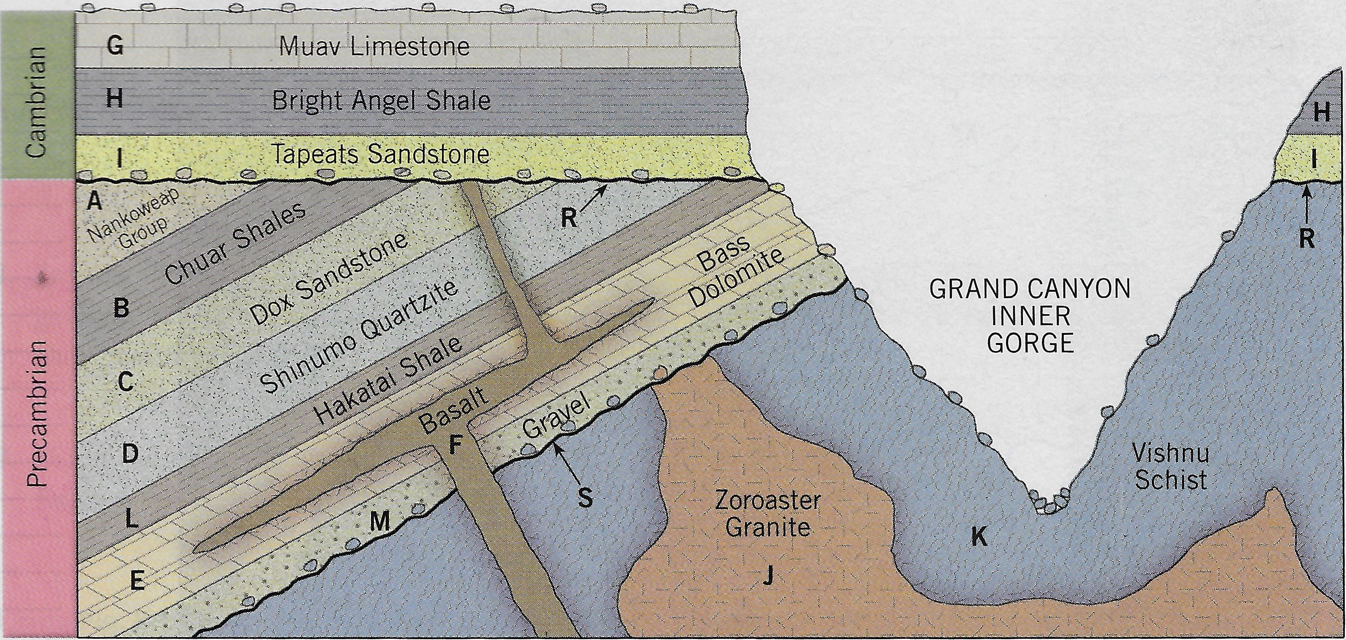

Oldest Youngest
K, ?, ?, ?, ?, ?, ?, ?, ?, ?, ?, ?, ?, ?, G
K, J, S, M, E, F, L, D, C, B, A, R, I, H, G
You will now apply the theory of radiometric dating. Answer the following questions by playing the University of Colorado Boulder’s Radioactive Dating Game simulation: https://archive.cnx.org/specials/d709a8b0-068c-11e6-bcfb-f38266817c66/radioactive-dating-game/ - sim-half-life

Click on the Dating Game+ tab at the top of the page. Fill in the age for the 11 items listed on the table below. Several “item” options have been removed (strikethrough and gray shaded) – do not provide ages for these removed “items”.
*Hint: For the last four items on the list, neither C-14 or U-238 will work well. Select “Custom”, and pick a half-life that gives you something other than 0.0% on the probe. Indicate the half-life used in the “Element Used” column. Use the Geologic Time Scale on p. 8 of your textbook to help you fill in the Geologic Era and Geologic Period information. (11 pts)

Item | Age | Element Used | Geologic Era | Geologic Period
Animal Skull | 130 | Carbon 14 | Mesozoic | Jurassic
Living Tree | 0 | Carbon 14 | Cenozoic | Quaternary
Bone | 1,477 | Carbon 14 | Mesoproterozoic | Calymmian
Rock 1 | 136,510,000 | Uranium 238 | Precambrian | Cretaceous
Rock 2 | 257,070,000 | Uranium 238 | Precambrian | Permian
Rock 3 | 455,640,000 | Uranium 238 | Precambrian | Ordovician
Rock 4 | 719,810,000 | Uranium 238 | Precambrian | Cryogenian
Rock 5 | 1,250,000,000 | Uranium 238 | Precambrian | Haden
Fish Fossil | 27,960,000 | 10m yrs | Paleogene | Oligocene
Dinosaur Skull | 154,910,000 | 100m yrs | Kimmeridgian | Jurassic
Trilobite | 308,870,000 | 100m yrs | Carboniferous | Moscovian

Navigate to http://climate.nasa.gov to answer the following questions.

Under the “Facts” tab on the opening webpage click on “Evidence”. What evidence is there that our Earth is undergoing rapid climate change? (Hint: Scroll the page!) (9 pts)
- Global Temperature Rise
  - Earth's average surface temperature has risen 2.12 degrees F (1.18°C) since the late 19th century
- Warming Ocean
  - The top 100 meters of the ocean shows warming of more than 0.6°F (0.33°C).
- Shrinking Ice Sheets
  - Data from NASA shows Greenland is losing an average of 279 billion tons of ice per year, while Antarctica is losing 148 billion tons of ice per year
- Glacial Retreat
  - Glaciers around the world are retreating.
- Decreased Snow Cover
  - Spring snow cover has decreased over the past 5 decades
- Sea Level Rise
  - Sea level rose about 8 inches since the last century and rate in the last 2 decades has doubled and is still increasing.
- Declining Arctic Sea Ice

- Extreme Events
  - The record high temperature events in the United States are increasing while the record low temperature events are decreasing.
- Ocean Acidification
  - The surface ocean waters acidity has increased by about 30% due to humans creating more carbon dioxide.

Under the “Facts” tab on the opening webpage click on “Vital Signs”. What are the five vital signs that scientists monitor to the climate health of Earth? Make sure to record the latest reading of each vital sign! (2 pts each; 10 pts total)
- Carbon Dioxide
- Global Temperature
- Arctic Sea Ice Extent
- Ice Sheets
- Sea Level
- Ocean Heat Content
What is the Scientific Consensus on Global Climate Change? (2 pts)
Scientific Consensus on Global Climate Change is a consensus on climate change and human activities is the main cause. Multiple studies published in peer-reviewed scientific journals show that human activities are the primary cause of the observed climate-warming trend over the past century. (https://climate.nasa.gov/scientific-consensus/)

